**Title:**

**Intentions of Landowners in South-central USA towards Active Management of Ecosystem for Deer Habitat Management**

**Authorship:**

(Given Name Middle Name (Or absent) Family Name, each author separated by commas).

Bijesh Mishra (विजेश मिश्र) a, Omkar Joshi a, Binod P. Chapagain ab, Lixia He Lambert c, Rodney E. Will a

**Affiliations:**

a Department of Natural Resource Ecology and Management, Oklahoma State University, Stillwater, OK, 74078

b Department of Integrated Biology, Oklahoma State University, Stillwater, OK, 74078

c Department of Agricultural Economics, Oklahoma State University, Stillwater, OK, 74078

**Corresponding Author:**

Bijesh Mishra:

Email: [Bijesh.mishra@okstate.edu](mailto:Bijesh.mishra@okstate.edu); [bjs.misra@gmail.com](mailto:bjs.misra@gmail.com)

Mailing address: 008C Agriculture Hall (212 N Monroe Street, 008C), Stillwater, OK, 74078

Figure 1: (a) Theory of Reasoned Action and (b) Theory of Planned Behavior.

(a)

(b)

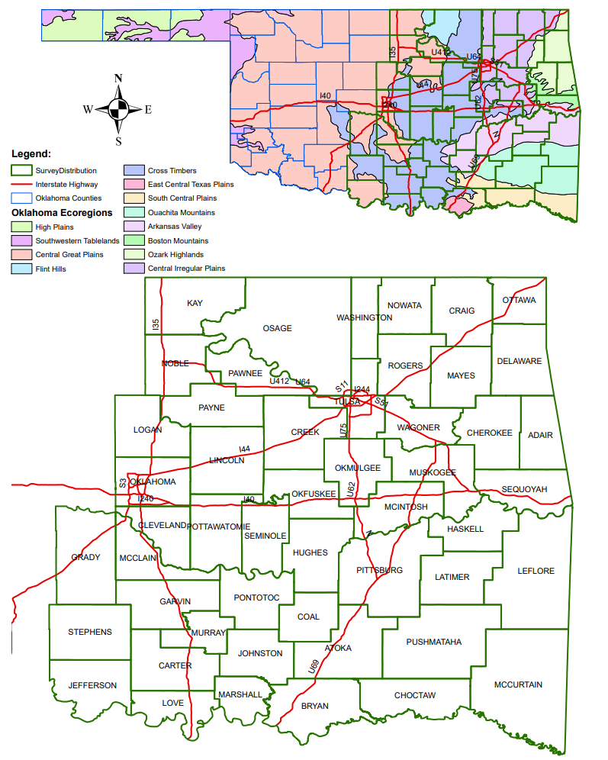

Figure 2: Study region: map of Oklahoma representing various ecoregions (top) and counties receiving surveys (bottom).

ns

- 0.31

0.84

0.75

ns

(b)

0.46

- 0.21

(a)

Figure 3: (a) Theory of Reasoned Action (TRA) and (b) Theory of Reasoned Action with Moral Norms (TRA-moral). Values on the arrow and “ns” indicate coefficients and “non-significant” relationships, respectively.

0.40

0.40

- 0.36

ns

ns

(a)

(b)

ns

- 0.33

ns

0.39

0.52

0.80

Figure 4: (a) Theory of Planned Behavior (TPB) and (b) Theory of Planned Behavior with Moral Norms (TPB-moral). Values on the arrow and “ns” indicate coefficients and “non-significant” respectively.

0.56

0.69

0.40

0.59

0.40

0.71